#### 

Medical Practice:

Database Design

Red Opal Innovations

Version 1

**Created by:** Viyada Tarapornsin

Table of Contents

Chen entity relationship diagram 3

Relational data model 4

Data dictionary 5

Crow’s Foot entity relationship diagram 11

Version control 12

Sign-off 12

# Chen entity relationship diagram

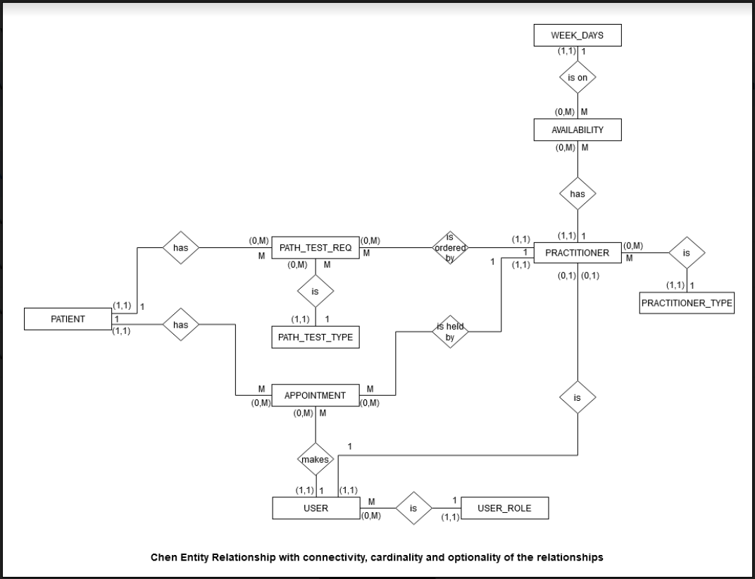

|  |
| --- |
| WEEK_DAYS |
| Day [PK] |

# Relational data model

|  |
| --- |
| PATH_TEST_REQ |
| PractitionerID [PK,FK] |
| DateOrdered [PK] |
| TimeOrdered [PK] |
| PatientID [FK] |
| TestType [FK] |

|  |
| --- |
| PATIENT |
| PatientID [PK] |
| Title |
| FirstName |
| MidInitial |
| LastName |
| AddressNumber |
| Street |
| Suburb |
| State |
| Postcode |
| HomePhone |
| MobilePhone |
| MedicareNumber |
| DOB |
| Gender |

|  |
| --- |
| AVAILABILITY |
| PractitionerID [PK,FK] |
| Day [PK,FK] |

|  |
| --- |
| PRACTITIONER |
| PractitionerID [PK] |
| Title |
| FirstName |
| MidInitial |
| LastName |
| AddressNumber |
| Street |
| Suburb |
| State |
| Postcode |
| HomePhone |
| MobilePhone |
| MedicareNumber |
| AHPRAMRN [AK] |
| DOB |
| Gender |
| PractitionerType [FK] |

|  |
| --- |
| PATH_TEST_TYPE |
| TestCode [PK] |
| TestName |
| Description |

|  |
| --- |
| APPOINTMENT |
| PatientID [PK,FK] |
| Date [PK,AK] |
| StartTime [PK,AK] |
| PractitionerID [FK,AK] |
| ReceptionistID [FK] |

|  |
| --- |
| USER |
| UserID [PK,FK] |
| UserRole [PK,FK] |
| Username [AK] |
| Password |
| Status |

|  |
| --- |
| PRACTITIONER_TYPE |
| PractitionerType [PK] |

|  |
| --- |
| USER_ROLE |
| UserRole [PK] |

# Data dictionary

| **MEDICAL PRACTICE SYSTEM**  **Data Dictionary** | | | | | | | | |
| --- | --- | --- | --- | --- | --- | --- | --- | --- |
| **TABLE NAME** | **ATTRIBUTE NAME** | **CONTENTS** | **DATA TYPE** | **FORMAT** | **RANGE** | **REQUIRED** | **PK, FK or AK** | **FK Referenced Table** |
| PATIENT | PatientID | Patient identification number, unique number, used to identify a patient in the system. It is an auto incremented field | INTEGER | nnnnn | 10000-99999 | Y | PK |  |
| Title | An abbreviation of the word in front of a patient’s name states his/her gender or qualifications, e.g. Dr, Miss, Ms, Mr, Mrs, etc | NVARCHAR(15) | Xxxx |  | Y |  |  |
| FirstName | First name of patient | NVARCHAR(30) | Xxxxxxx |  | Y |  |  |
| MidInitial | Middle initial of patient’s name | CHAR(1) | X |  |  |  |  |
| LastName | Last name of patient | NVARCHAR(40) | Xxxxxxx |  | Y |  |  |
| AddressNumber | Street and unit number of patient’s address | NVARCHAR(10) | nnn/nnn  nnnnn |  | Y |  |  |
| Street | Street or road name of patient’s address | NVARCHAR(40) | Xxxxxxx |  | Y |  |  |
| Suburb | Suburb where patient lives | NVARCHAR(40) | Xxxxxxx |  | Y |  |  |
| State | Abbreviation of state in Australia where patient lives, including NSW, VIC, SA, NT, TAS, QLD, WA, and ACT | NVARCHAR(3) | XXX |  | Y |  |  |
| Postcode | Postcode of patient’s address in Australia, e.g. 2000, 3516, 0458 | NVARCHAR(4) | XXXX |  | Y |  |  |
| HomePhone | Home phone number of patient | NCHAR(10) | xxxxxxxxxx |  |  |  |  |
| MobilePhone | Mobile phone number of patient | NCHAR(10) | xxxxxxxxxx |  |  |  |  |
| MedicareNumber | Medicare number of patient who has one | NCHAR(10) | xxxxxxxxxx |  |  |  |  |
| DOB | Date of birth of patient | DATE | dd/mm/yyyy |  | Y |  |  |
| Gender | Gender of patient, e.g. Female, Male, Transgender, Unspecified | NVARCHAR(20) | Xxxxx |  | Y |  |  |
| USER_ROLE | UserRole | Role of users in the system. It can be Receptionist or Practitioner | NVARCHAR(30) | Xxxxxxxxx |  | Y | PK |  |
| USER | UserID | The user identification of the user in the system. If the user is a practitioner, this number is the same as his/her practitioner id in the practitioner table.  In the future, this id is used with the UserRole field to identify the user of the system when there are more user roles and other user roles’ personal information is kept in the system. | INTEGER | nnnnn | 10000-99999 | Y | PK, FK | PRACTITIONER, APPOINTMENT |
| UserRole | Role of users in the system. It can be Receptionist or Practitioner | NVARCHAR(30) | Xxxxxxxxx |  | Y | PK, FK | USER_ROLE |
| Username | Unique username, each user in the system has his/her own username to login to the system | NVARCHAR(20) | xxxxxxxxxx |  | Y | AK |  |
| Password | Password of user to login to the system | NVARCHAR(30) | xxxxxxxxxx |  | Y |  |  |
| Status | Status of users in the system either Active or Inactive | BOOLEAN | Active,  Inactive |  | Y |  |  |
| PRACTITIONER_TYPE | PractitionerType | Type of practitioner, e.g. Medical practitioner, Midwife, etc | NVARCHAR(40) | Xxxxxxxxxx |  | Y | PK |  |
| PRACTITIONER | PractitionerID | Practitioner identification number, unique to each practitioner. It is an auto incremented field | INTEGER | nnnnn | 10000-99999 | Y | PK |  |
| Title | An abbreviation of the word in front of a practitioner’s name states his/her gender or qualifications, e.g. Dr, Miss, Ms, Mr, Mrs, etc | NVARCHAR(15) | Xxxx |  | Y |  |  |
| FirstName | First name of practitioner | NVARCHAR(30) | Xxxxxxxx |  | Y |  |  |
| MidInitial | Middle initial of practitioner’s name | CHAR(1) | X |  |  |  |  |
| LastName | Last name of practitioner | NVARCHAR(40) | Xxxxxxx |  | Y |  |  |
| AddressNumber | Street and unit number of practitioner’s address | NVARCHAR(10) | nnn/nnn  nnnnn |  | Y |  |  |
| Street | Street or road name of practitioner’s address | NVARCHAR(40) | Xxxxxxx |  | Y |  |  |
| Suburb | Suburb where practitioner lives | NVARCHAR(40) | Xxxxxxx |  | Y |  |  |
| State | Abbreviation of state in Australia where practitioner lives, including NSW, VIC, SA, NT, TAS, QLD, WA, and ACT | NVARCHAR(3) | XXX |  | Y |  |  |
| Postcode | Postcode of practitioner’s address in Australia, e.g. 2000, 3516, 0458 | NVARCHAR(4) | XXXX |  | Y |  |  |
| HomePhone | Home phone number of practitioner | NCHAR(10) | xxxxxxxxxx |  |  |  |  |
| MobilePhone | Mobile phone number of practitioner | NCHAR(10) | xxxxxxxxxx |  |  |  |  |
| MedicareNumber | Medicare number of practitioner who has one | NCHAR(10) | xxxxxxxxxx |  |  |  |  |
| AHPRAMRN | AHPRAMRD is the AHPRA medical registration number of a practitioner. Each practitioner can be registered under one registration. This is a unique number each practitioner. | NCHAR(10) | xxxxxxxxxx |  |  | AK |  |
| DOB | Date of birth of practitioner | DATE | dd/mm/yyyy |  | Y |  |  |
| Gender | Gender of practitioner, e.g. Female, Male, Transgender, Unspecified | NVARCHAR(20) | Xxxxx |  | Y |  |  |
| PractitionerType | Type of practitioner, e.g. Medical practitioner, Midwife, etc | NVARCHAR(40) | Xxxxxxxxxx |  | Y | FK | PRACTITIONER_TYPE |
| WEEK_DAYS | Day | Weekdays, including Monday, Tuesday, Wednesday, Thursday, and Friday | NVARCHAR(9) | Xxxxxxxxx |  | Y | PK |  |
| AVAILABILITY | PractitionerID | Practitioner identification number, who has this day available | INTEGER | nnnnn | 10000-99999 | Y | PK, FK | PRACTITIONER |
| Day | Weekdays, including Monday, Tuesday, Wednesday, Thursday, and Friday | NVARCHAR(9) | Xxxxxxxxx |  | Y | PK, FK | WEEK_DAYS |
| APPOINTMENT | PatientID | Patient identification number, who has the appointment | INTEGER | nnnnn | 10000-99999 | Y | PK, FK | PATIENT |
| Date | Date of the appointment | DATE | dd/mm/yyyy |  | Y | PK, AK |  |
| StartTime | Time of the appointment | TIME | 00:00 AM/PM |  | Y | PK, AK |  |
| PractitionerID | Practitioner identification number, who the appointment is with | INTEGER | nnnnn | 10000-99999 | Y | FK, AK | PRACTITIONER |
| ReceptionistID | Receptionist identification number, who makes the appointment for the patient. It is a unique number for each receptionist | INTEGER | nnnnn | 10000-99999 | Y | FK | USER |
| PATH_TEST_TYPE | TestCode | Pathology test code | NVARCHAR(20) | Xxxxxxxx |  | Y | PK |  |
| TestName | Full name of the pathology test | NVARCHAR(100) | Xxxxxxxxxxx |  | Y |  |  |
| Description | Description of the pathology | NVARCHAR(500) | Xxxxxxxxxx |  |  |  |  |
| PATH_TEST_REQ | PractitionerID | Practitioner identification number, who orders the test | INTEGER | nnnnn | 10000-99999 | Y | PK, FK | PRACTITIONER |
| DateOrdered | Date that the test is ordered | DATE | dd/mm/yyyy |  | Y | PK |  |
| TimeOrdered | Time that the test is order | TIME | 00:00 AM/PM |  | Y | PK |  |
| PatientID | Patient identification number, for whom the test is | INTEGER | nnnnn | 10000-99999 | Y | FK | PATIENT |
| TestType | Pathology test type that has been ordered | NVARCHAR(20) | Xxxxxxxx |  | Y | FK | PATH_TEST_TYPE |

|  |
| --- |
| PK = Primary Key  FK = Foreign Key  AK = Alternate Key  NCHAR = Fixed length Unicode Character Data  NVARCHAR = Variable length Unicode Character Data |

# Crow’s Foot entity relationship diagram

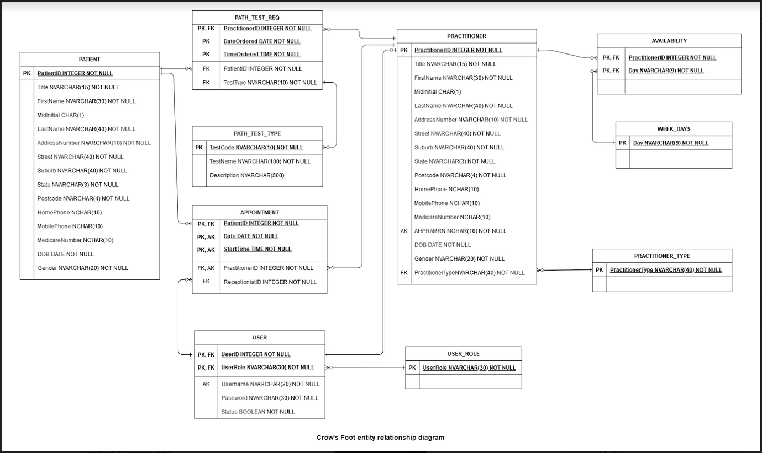

# Version control

|  |  |  |  |
| --- | --- | --- | --- |
| No | Effective | Approved by | Updates |
| 1 | 12 November 2020 | Wendy Opal  Director | Initial release |

# Sign-off

|  |  |  |  |
| --- | --- | --- | --- |
| Name | Position/role | Date | Signature |
|  |  |  |  |